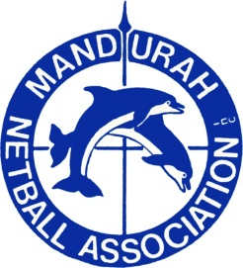

MANDURAH NETBALL ASSOCIATION
Application for TDS Coaching Position
Please complete the following and return to mnadevelopment@hotmail.com Thank you.
I wish to apply for the following position (Select which one is applicable)
TDS Lead Coach
TDS Assistant Coach
Preferred Age Group (Select the applicable – more than one preference can be selected)
Please note as discussed with committee and regional representatives coaches cannot be related to any athletes in their preferred age group.
17U Division 1
17U Division 2
15U Division 1
15U Division 2
14U Division 1
14U Division 2
14U Division 3
13U Division 1
13U Division 2
13U Division 3
12U Division 1
12U Division 2
12U Division 3

Please note your coaching history and your current Coaching Accreditation level below.
Accreditations must be up to date and attached to this application

